2520030413
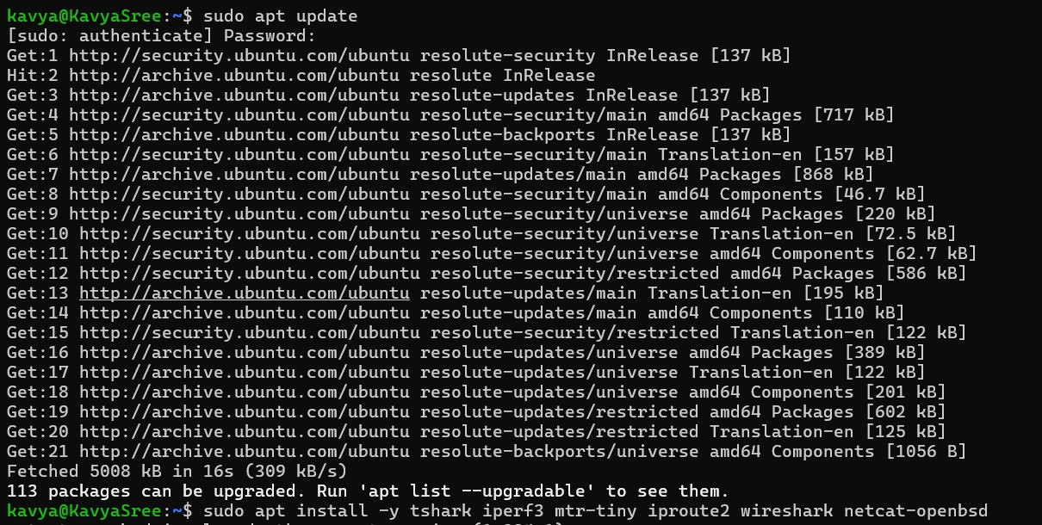
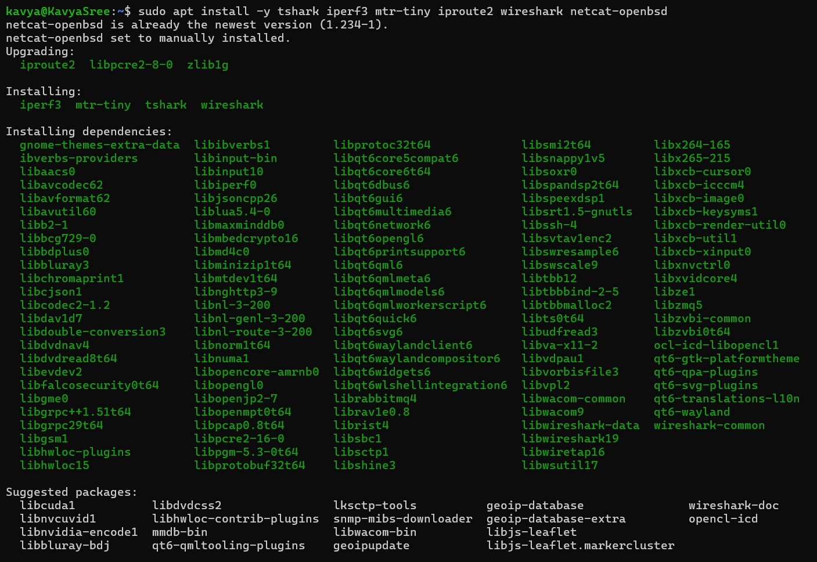
STAGE-1:

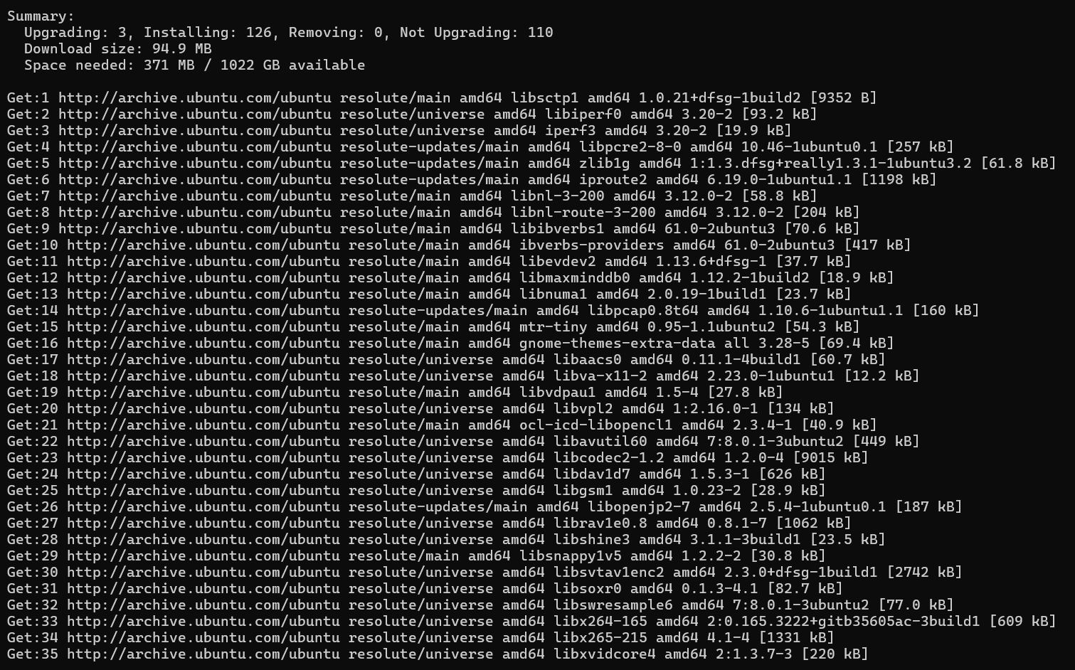

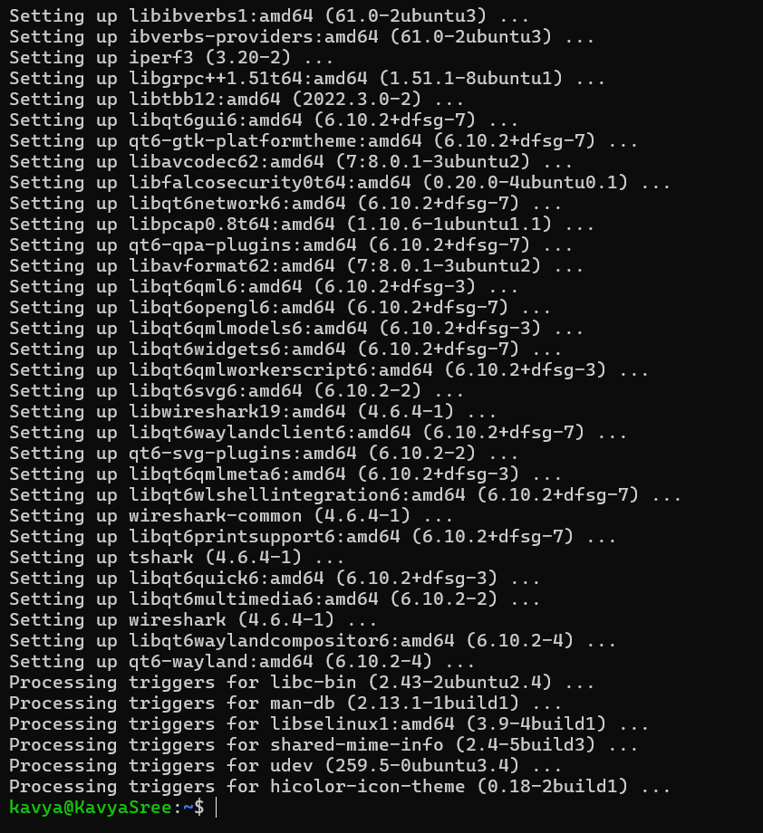
STAGE-2:
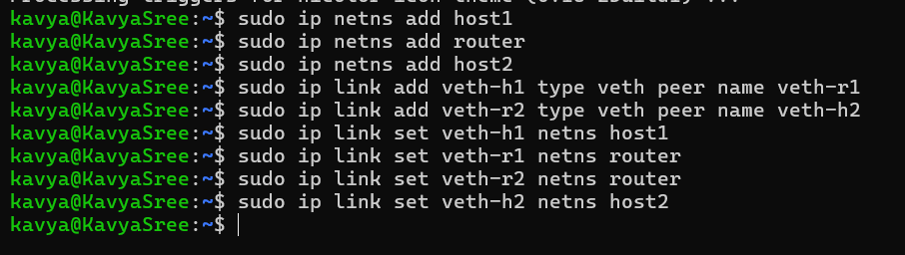

STAGE-3:
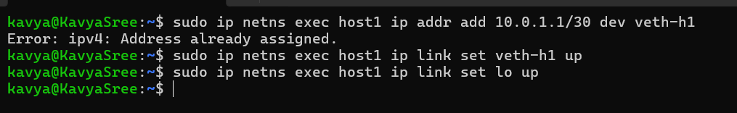
Host:

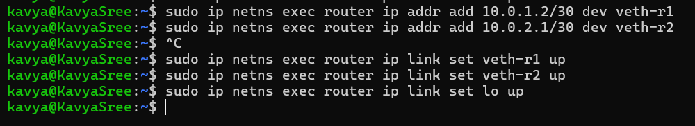
Router:

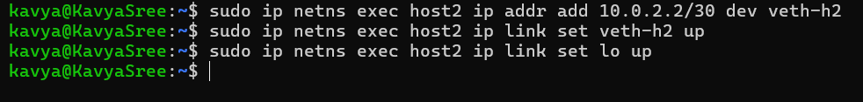
Host-2:

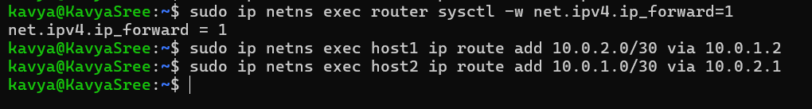
STAGE-4:

STAGE-5:
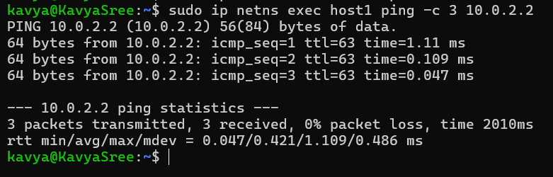

STAGE-6:

STAGE-7: Opening 4 Terminals STAGE-8:
Terminal-1:

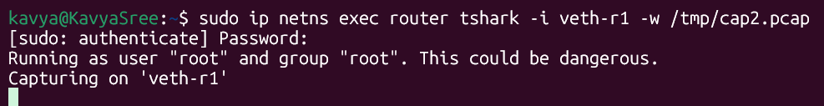
Terminal-2:

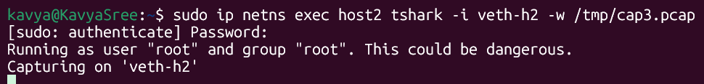
Terminal-3:

STAGE-9:
Terminal-4:
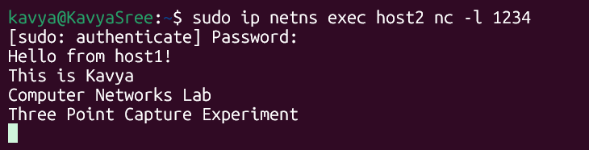
Terminal-5:
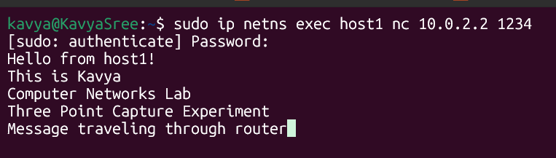

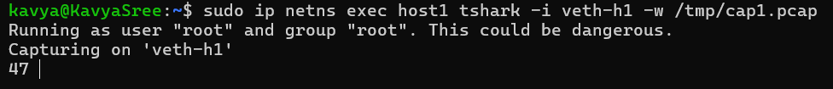
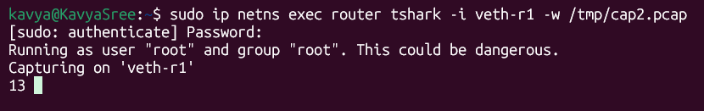
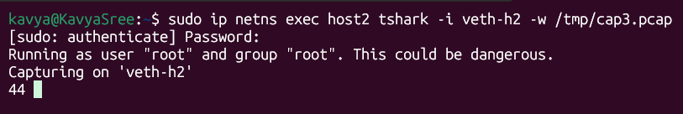
STAGE-10 & 11:

STAGE-12: Fix Permissions STAGE-13:

STAGE-14:
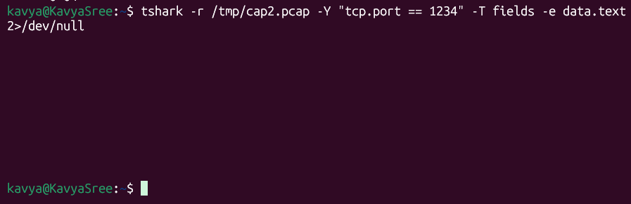

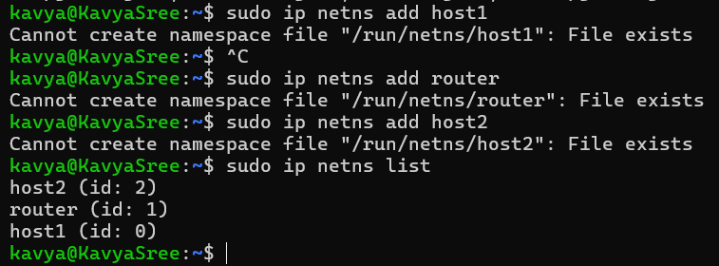
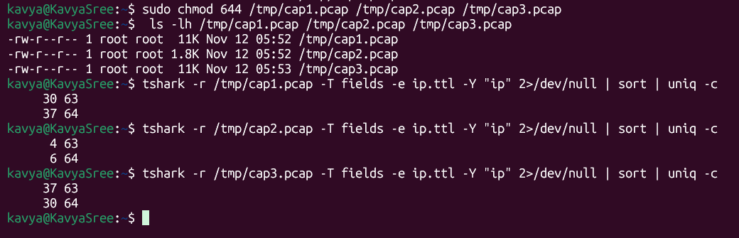
STAGE-15:

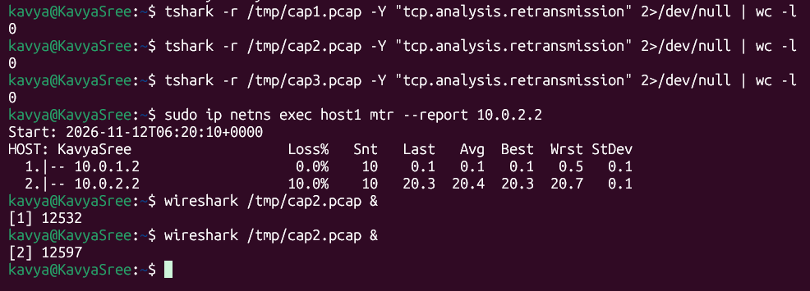
STAGE-16:



